**Assignment 7 – Practicing Reactive Forms**

Now's the time to practice the things you learned! In this assignment, you're going to build your own form using the reactive approach.

The snapshot below explains the example app you're starting with and which tasks should be completed as part of this assignment.

Make sure to also answer why you implemented the solution you chose to use.

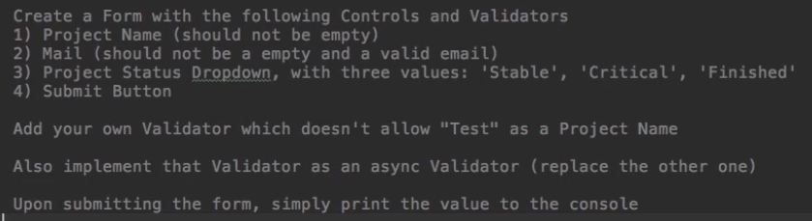

**Questions for this assignment**

**Please complete the tasks outlined in the instructions above. Why did you choose the approach you took? Which problems did you encounter?**

**Download resource files**

* forms-reactive-assignment-start.zip